Citizenship, Economics and Society (Secondary 1-3)
“3-minute Concept” Animated Video Clips Series:
“Self-concept”
Teaching Guidelines

1. Title of the animated video clip: “Self-concept”
2. Duration of the animated video clip: Around 3 minutes
3. Related CES Module: Module 1.1 Self-understanding and Life Skills
4. Introduction of the animated video clip: The animated video clip was developed by the Personal, Social and Humanities Education Section, Curriculum Development Institute, Education Bureau. It uses daily examples and simple language to succinctly explain the concept of “Self-concept”.
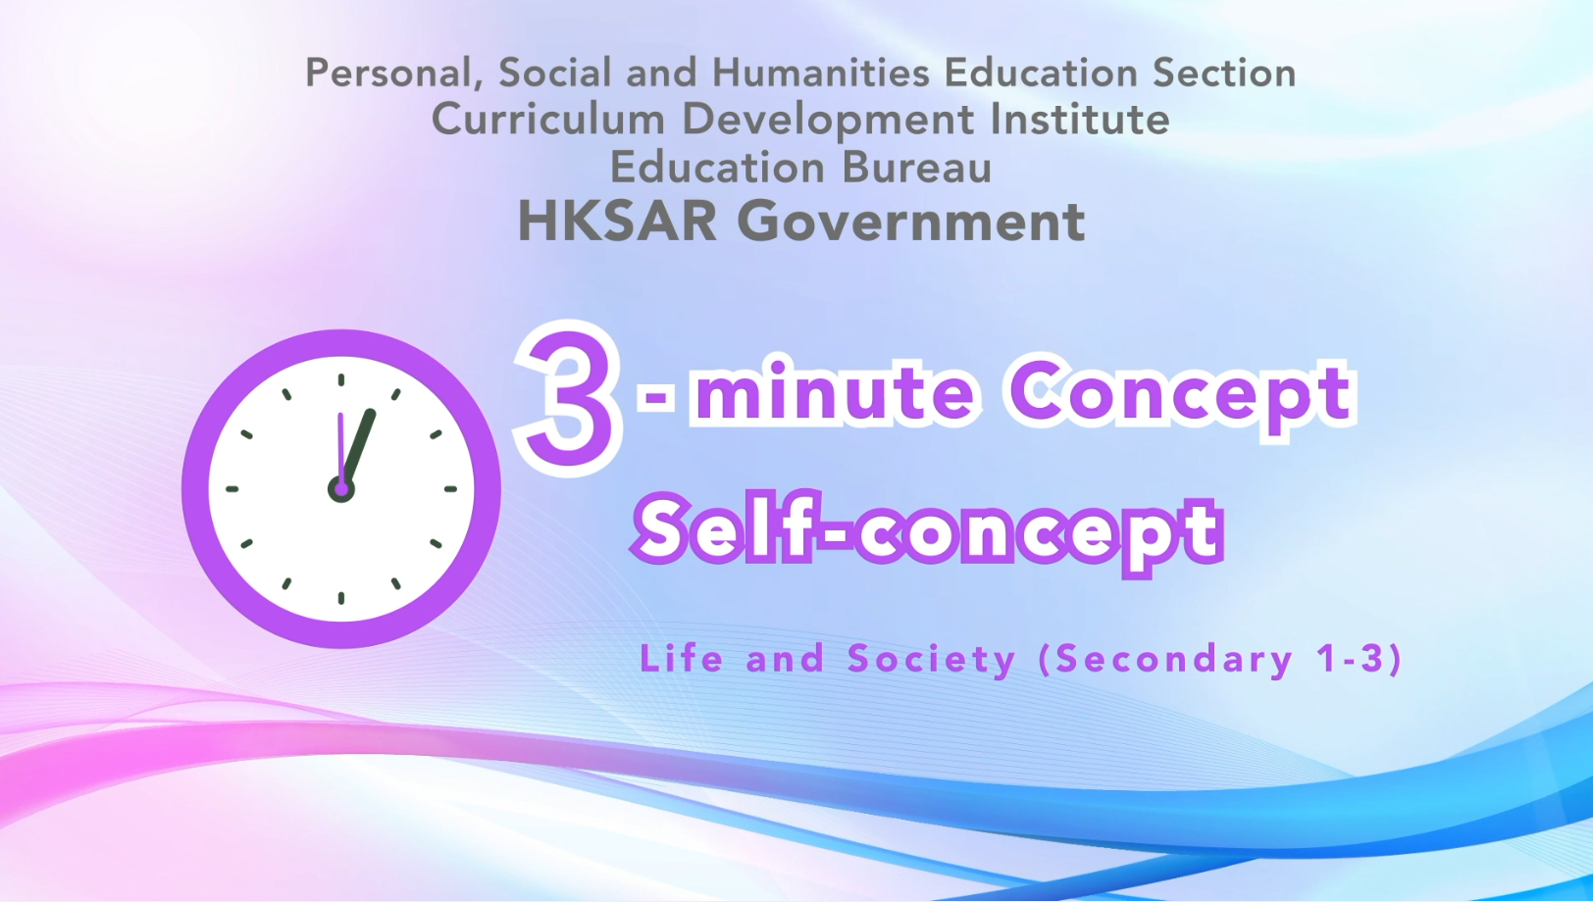
Citizenship, Economics and Society (Secondary 1-3)
Video link: https://emm.edcity.hk/media/Citizenship%2C+Economics+and+Society+%223-minute+Concept%22+Animated+Video+Clips+SeriesA+%288%29+Self-concept+%28English+subtitles+available%29/1_hnjnfh5e
5. Teaching tips: Teachers must explain the following main points to students after playing the “Self-concept” animated video clip:
1) Ways to develop a positive self-concept | - Teachers should point out to students that developing a positive self-concept and acquiring various life skills are most important for adolescents’ physical and psychological development. Teachers should further point out to students that everyone has strengths and weaknesses and that students should accept and appreciate their uniqueness and should not compare themselves to others. Teachers can advise students to participate in physically and psychologically beneficial activities to learn about their interests, abilities, aspirations and potentials. Students should be open to suggestions from teachers, take the initiative to improve themselves, face the challenges of growth with an optimistic and positive attitude, and work hard for their own lives and the common good of society. For details on the psychological health of adolescents, teachers can refer to the following resource:  Student Health Service - Psychological Health of Adolescents  https://www.studenthealth.gov.hk/english/health/health_ph/health_ph_young.html
2) Beware of undesirable behaviours and enhance self-concept | Teachers should point out to students that leading a healthy and meaningful life, developing good behaviours, and cultivating the habit of devoting themselves to the public good are important for adolescents. Teachers should further point out to students that adolescents are not mentally and psychologically mature. Some adolescents with relatively weak self-concepts may think that they cannot gain recognition from others through positive behaviours and wrongly believe that they can highlight their self-worth through undesirable behaviours, such as smoking or bullying, and gain the recognition of others. Teachers must earnestly point out to students the serious impacts of undesirable behaviours on adolescents, their families, friends and society, including the negative impacts on personal prospects and legal liabilities. Students should participate in healthy group activities, sports activities and community services to develop talents and acquire a sense of success and satisfaction.
3) The Government of the Hong Kong Special Administrative Region’s policy on supporting youth development | - Teachers should point out to students that the Government of the Hong Kong Special and Administrative Region is committed to providing a varity of training, exchange and entrepreneurial opportunities for young people in Hong Kong, to help them understand the employment trends, set short-term and long-term life goals, seize development opportunities, meet future challenges and contribute to society and our country. Teachers can further explain to students the following initiatives by the Hong Kong Government: 1) The Home and Youth Affairs Bureau (HYAB) released the Youth Development Blueprint in December 2022, which outlines the vision and direction, specific actions, measures and performance indicators for the long-term youth development work of the Hong Kong Government, and the HYAB will take the lead to coordinate the implementation of the blueprint with relevant bureaux; 2) The Government set up the Youth Development Commission in 2018 to promote cross-bureau and interdepartmental collaboration to promote young people’s development actively, and its work includes facilitating young people’s selection of suitable study pathways, assisting in their career development and upward mobility, and strengthening communication channels with young people. For the youth development work responsible by the Home and Youth Affairs Bureau and Youth Development Commission, please refer to the following resources:  Home and Youth Affairs Bureau - Youth Development  https://www.hyab.gov.hk/en/policy_responsibilities/Social_Harmony_and_Civic_Education/youth.htm  Youth Development Commission - Youth Development Programmes  https://www.ydc.gov.hk/en/programmes/introduction.html

6. Consolidation questions: (See next page)

“3-minute Concept” Animated Video Clips Series:

“Self-concept”

Worksheet

- Fill-in-the-blank questions
Write the correct answers in the spaces provided.
Psychologist Carl Rogers proposed that “Self-concept” is made up of three components, including:

(how others think of us)
Self-concept
(the way we think about ourselves)

(what kind of a person you want to be)
Perceived self

Ideal self
Real self

- Matching
Match the following examples with the three components of “Self-concept”.

Examples Three Components of
“Self-concept”

Yuen Wai loves singing. She has never won a prize despite numerous attempts. She believes that after ceaseless polishing, she will become a singer. |  |  |  | Real self
Chi Fai wants everything to be perfect. He thinks that his classmates find him very picky about everything. But in fact, they think he is serious and careful. |  |  |  | Ideal self
Chui Yi is fond of many sports and she is the volleyball team captain. She thinks that she is an active person. |  |  |  | Perceived self

C. Short Question
How can we better understand ourselves?
Suggested answer:
We should try to conduct better communications with teachers, family
and trusted friends about our thoughts; listen to their advice and
reflect on our own self-understanding.

The End

